Menu Setup!
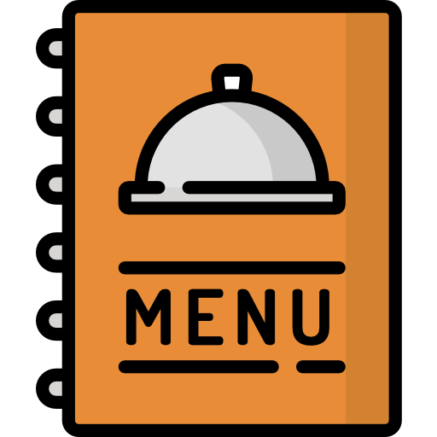

Menu Setup Challenge: Channel Your Inner Onboarding Executive 🎯

The purpose of this task is to help you get hands-on experience with menu setup—just like an Onboarding Executive! Upskilling starts here. 💪

Below, you’ll find a table linking to real merchant tickets where they’ve sent their menus and requested item setups in their BackOffice.

Menu Setup Links
F&B | Link
Retail | Link
Here’s what you need to do:
- Open the Request section in each ticket and review the merchant’s menu.
- Use your BackOffice account (the one you created on Day 1) to set up the items from these tickets.
- Create at least 20 products each for both F&B and Retail businesses.
- Example: From the F&B Intercom ticket, add 20 products.
- From the Retail Intercom ticket, add another 20 products.

Once you're done, it’s time to show off your skills! Inform your Buddy to review your work by sharing access to your BackOffice. Don’t forget to add them as an employee to give them a peek at your setup.

Good luck—and may your menus be as smooth as your skills! 🍔🛍️

